**ЗАДАНИЕ 1**

**1)**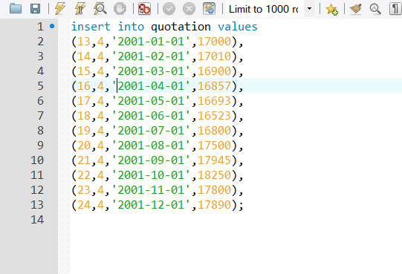

insert into quotation values

(13,4,'2001-01-01',17000),

(14,4,'2001-02-01',17010),

(15,4,'2001-03-01',16900),

(16,4,'2001-04-01',16857),

(17,4,'2001-05-01',16693),

(18,4,'2001-06-01',16523),

(19,4,'2001-07-01',16800),

(20,4,'2001-08-01',17500),

(21,4,'2001-09-01',17945),

(22,4,'2001-10-01',18250),

(23,4,'2001-11-01',17800),

(24,4,'2001-12-01',17890);

